**Data-driven Sales and Demand Prediction for Electrical Appliance Supplier**

**Mid Term Submission Report**

Submitted by

Trivedhan Sivaprakash

21F1001724



IITM Online BS Degree Program,

Indian Institute of Technology, Madras, Chennai

Tamil Nadu, India, 600036

**Data-driven Sales and Demand Prediction for Electrical Appliance Supplier**

**Executive Summary**

The project's main goal is to create a reliable and precise forecasting model for predicting sales and demand for an Electrical Appliance supply company. This company specializes in wholesaling and bulk distribution of Electric Appliances, including products like Water heaters, Stabilizers, Grinders, and Fans from renowned brands such as Vguard and Crompton. Their customers consist of dealers across the district. The business faced a significant decline in revenue during the COVID-19 pandemic, which the owner attributed to inadequate preparation and inefficient inventory management. This project aims to address this issue by developing a solution.

The approach involves considering a range of internal and external factors such as historical sales data, seasonal patterns, customer retention, inflation, and more. The primary objective is to build a robust predictive model that can anticipate fluctuations in sales and demand. The collected data will be subjected to thorough cleaning and formatting for effective analysis. Utilizing this refined data, a predictive Sales Forecast model will be constructed using various tools and Python modules such as Excel, Scipy, Sklearn, Linear Regression, and Pareto analysis.

Furthermore, techniques like Pareto analysis will be executed to detect noteworthy trends. The ultimate outcome of this project is to provide accurate forecasts for sales and demand, thereby assisting in optimizing the company's profitability.

**Process of Data Collection and Proof of Originality**

The chairman and owner of the organization is Mr. S Srinivasan and he facilitated with the process of Data collection. The organization initially started as a distribution center for Polar Fans, Heaters and Stabilizers and Cookware products for 5 organizations and had a coverage of up to 2 districts in Tamil Nadu. However, due to COVID-19, the overall revenue generated had drastically dropped down and the number of organizations whose products were distributed dropped down to two. Now, he hopes to increase his organizational strength back to 5+ and hope to grow more and surpass his pre-covid revenue.

Figure 1: Mr. Srinivasan – The Chairman

Upon contacting Mr. Sreenivasan, he was very forthcoming in providing the datasets necessary for the analysis. We connected with him on the 10th of July, 2023 and he provided the Sales and the Purchase Order Data of his company for a duration of 6 months (1stJan, 2023 – 30th June, 2023). As a test for originality

Figure 2: Organization

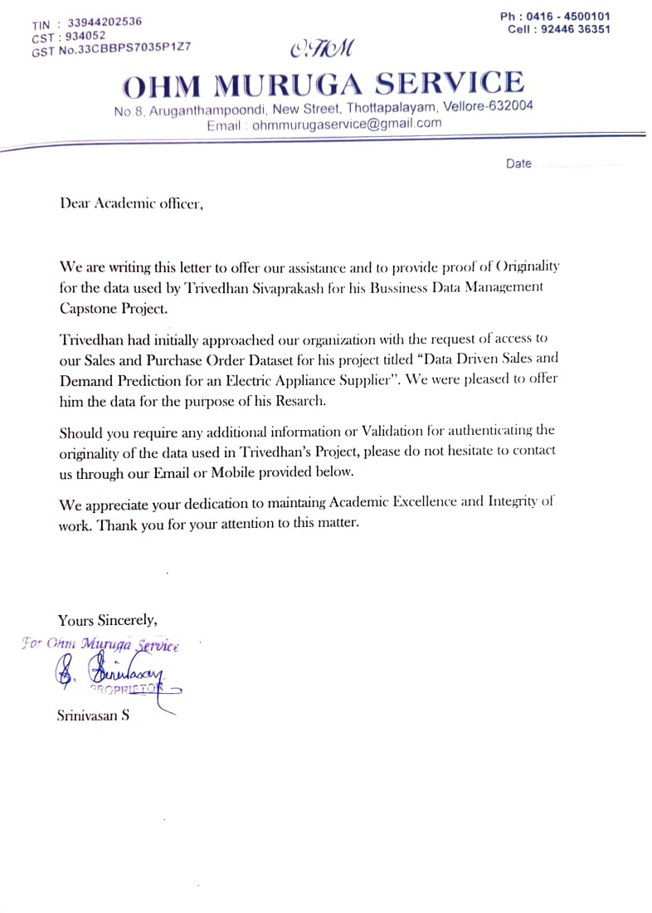

Figure 3: Proof of Originality

**Metadata and Descriptive Statistics**

1. **Sales Dataset**

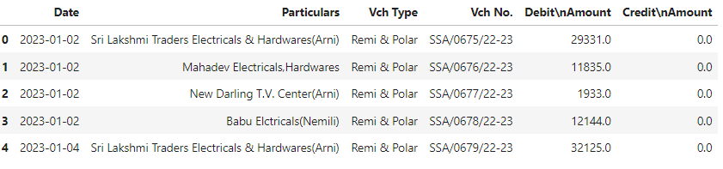

Figure 4: Sales Dataset Data Sample

About the Dataset:

The sales dataset comprises of list of records generated by SS Services that outlines the customer’s request to purchase the respective goods from their organization. This dataset has 515 records spanning from 1st Jan to 30th June, 2023.

Size of the Dataset: 516 Rows X 4 Columns [Inclusive of the headers]

Column Description:

* Date: It is the date of execution of the Sales Receipt
* Particulars: The Customer Name/Organization
* Vch. Type: Payment Voucher Type
* Debit Amount: The total price of the executed Sales

Data Preprocessing:

An extra column was added to cover the month of the sales called the **Month** column for a better analysis of the provided data.

**Descriptive Statistics**

This data was analyzed to understand the following pertinent features about the columns.

1. **Customer:**  The 515 Records had a total of 153 customers who had placed orders for the necessary items. Out of those, the top 15 orders are placed by the following organizations.

Chart 1: The count of Sales by Each Individual/Organization

The majority of the orders placed are by Individual Customers rather than any organizations purchasing it in Bulk.

1. **Voucher Type:**  There are 2 predominant Voucher types used by the company during purchase.
2. **Debit Amount:**  To understand the spread of the sales, the individual amount was spread in a histogram to understand the average purchases made.

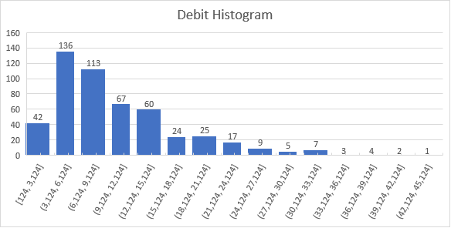

Chart 3: Histogram of Debit Amount

On further numerical analysis, the following values were obtained that help in better understanding the data provided.

|  |
| --- |
|  |

|  |  |
| --- | --- |
| **Parameters** | **Value** |
| **Mean** | 10331.747 |
| Std.Deviation | 7502.0836 |
| Minimum | 124 |
| Maximum | 43096 |
| Count | 515 |

Table 1: Descriptive Statistics of Sales Order Dataset

1. **Purchase Order Dataset**

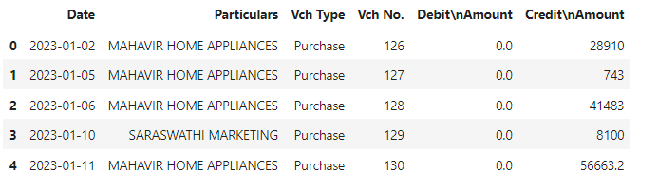

Figure 5: Purchase Dataset Data Sample

About the Dataset:

The purchase dataset comprises of list of records generated by SS Services that outlines it’s request to purchase the respective goods from the vendors. This dataset has 112 records spanning from 1st Jan to 30th June, 2023.

Size of the Dataset: 113 Rows X 4 Columns [Inclusive of the headers]

Column Description:

* Date: It is the date of execution of the Purchase Order
* Particulars: The Vendor Name/Organization
* Vch Type: Payment Voucher Type
* Credit Amount: The total price of the Purchase Order

Data Preprocessing:

An extra column was added to cover the month of the sales called the **Month** column for a better analysis of the provided data.

**Descriptive Statistics**

This data was analyzed to understand the following pertinent features about the columns.

1. **Vendor:**  The 112 Purchase Records had a total of only 5 where the items are procured from. Out of those, the top 15 orders are placed by the following organizations.

Chart 4: Purchase Count with Each vendor

1. **Voucher Type:**  There is just direct purchase from the vendor and therefore this column is redundant.
2. **Credit Amount:** The amount spent on vendors for the purchase of goods is spread in a histogram for better understanding and analysis of data.

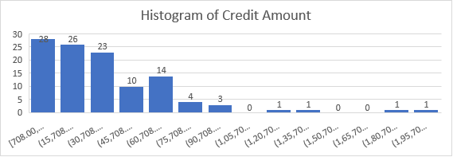

Chart 5: Histogram of Credit Amount

On further numerical analysis, the following values were obtained that help in better understanding the data provided.

|  |  |
| --- | --- |
| **Parameter** | **Value** |
| **Mean** | 40145.51964 |
| Std. Deviation | 35422.59946 |
| Minmium | 708 |
| Maximum | 208447 |
| Count | 112 |

Table 2: Desriptive Statistics of Purchase Order

**Detailed Explanation of the Analysis Process and Methods**

The following method was decided for performing Sales Forecasting with the provided Data.

1. The Moving Average for the overall data needs to be calculated for a set timeframe (In this case, 1 week). This helps in setting the baseline.
2. The scope of prediction for this model is expected to be the next 6 months based on the provided data. This helps in setting the prediction target.
3. The derived Moving Average is then extended to the rest of the expected target to obtain the forecast. This would help in identifying the forecast.
4. This analysis will also be done in python by using more elaborate Regression techniques for better prediction.

However, to make a contrast with this, the analysis will further be performed in python for a more accurate prediction to be made.

**Results and Findings**

A comprehensive analysis of the Dataset was performed and the following observations were made that would contribute greatly to further understanding our issue.

1. The monthly sales of the organization had seen a steep incline between the month’s January to April and then begins to stabilize after that. This can be viewed in the chart provided below.

Chart 6: Sales Analysis by Month

1. On analyzing the Top 15 Sales made with respect to the customer, the top 5 most sales were in bulk by wholesale organizations. This is in contrast to the comparison made in Chart 1 where the most number of orders were placed by individual customers rather.

Chart 7: Sales with reference to Customer

1. On analyzing the Purchase Order Dataset, most of the purchase is obtained from Mahavir Appliances making it the most reliable vendor in contrast to other vendors.

This could be used for obtaining discounts and other exceptions during purchase.

Chart 8: Purchase Orders based on Shops

1. The monthly purchase orders placed is displayed in the chart below. The purchase order follows the same pattern as the sales order. It increases from the beginning and begins stabilizing later.